TITLE OF THE PAPER [FONT: ARIAL 14PTS]

First A. Author*¹, Second B. Author2 and Third C. Author3 [Font: Arial 12pts]

^{1, 2} Authors’ Department, Institute, City, COUNTRY.
(E-mail: firstauthorsname@aaaa.bbb, secondauthorsname@aaaa.bbb)
³ Author’s Department, Institute, City, COUNTRY.
(E-mail: thirdauthorsname@aaaa.bbb)
[Font: Arial 10pts]

ABSTRACT [FONT: ARIAL 14PTS]
The abstract should not be more than 300 words each. The abstract should not only indicate the subject and scope of the paper but also summarize the author’s conclusion. Structured abstract must be a brief, comprehensive summary of the contents of the article. It allows readers to survey the contents of an article quickly. An Abstract summarizes the major aspects of a paper. It should succinctly summarize the purpose of the paper, the methods used, the major results, and conclusions. [Font: Arial 12pts]
Keywords : Keyword 1, Keyword 2, Keyword 3 (Min 3 key words & Max 5 Key words) [Font: Arial 10pts]

1.0 INTRODUCTION [FONT: ARIAL 14PTS]
[Font: Arial 12pts; No indentation] This format is to be used for submissions that are published in the proceeding of the GBES 2021. We wish to give this proceeding a consistent, high-quality appearance. We therefore ask that authors follow some simple guidelines. The best is to read these instructions and follow the outline of this text. Please make the page settings of your word processor to A4 format (21 x 29.7 cm or 8 x 11 inches); with the margins: bottom/top 1.6 cm (0.63 in), right/left margins must be 2 cm (0.79 in).

[NOTE: No indentation, 1 space between paragraphs] This format is to be used for submissions to be considered in journal publication. We therefore ask that authors follow some simple guidelines. In essence, you should format your paper exactly like this document. The easiest way to do this is simply to download a template from the conference web site, and replace the content with your own material.

The full paper should be written in MS Word format in single-spaced in 12 point Arial. Do not indent the text paragraphs. Please state clearly the aim and scope of the study, the materials and methods, and the main findings and brief analysis of the study. Please observe Figure 1 and Table 1 to include figures and tables in the abstract, respectively.

Authors are requested to submit the full paper (6-8 pages or 5500-7500 words in length including abstracts and references) in electronic form (MS-Word) via our Online Submission. The incorrect formats may result that your full paper will not be considered for journal publications.

A digital version of the GBES 2021 Proceeding will be published in the conference website. After the conference, selected full papers will be invited publishing in indexed journals or periodicals.

2.0 MAIN RESULTS

2.1 Sections Headings [Font: Arial, Titlecase, Bold, Italic, 12pts]

Figures can be included in your full paper and referred to in the text as Figure 1, Figure 2, and so on. Figure in this context could be diagrams, graphs, charts, illustrations, maps or any graphic representation. The title for the figure should be put after the figure shown.
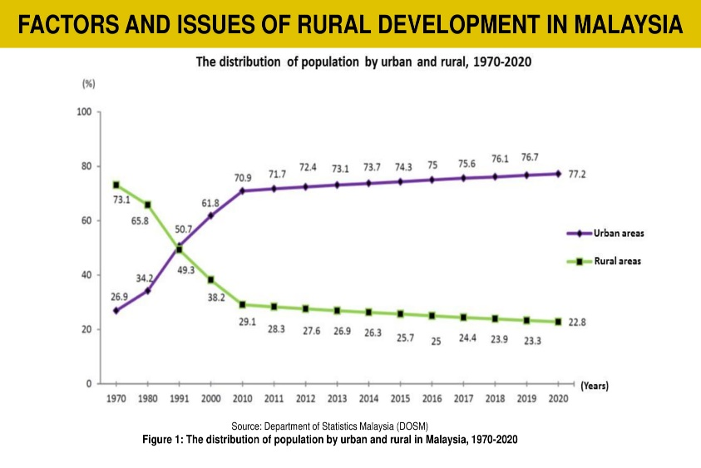
Figure 1 [Font: Arial 12pts] Example of figure for the extended abstract [Font: Arial 12pts]

A table should be inserted like the one below and referred in the text as Table 1, Table 2 and so on. The title for the table should be put before the content table.

Table 1 [Font: Arial 12pts] Example of table for the extended abstract [Font: Arial 12pts]

Title of Content [Font: Arial, Bold Titlecase. Size: varies, fits to space]
Body Content [Font: Arial, Size: varies, fits to space]

2.2 Special Signs

For example, α γ μ Ω () ≥ ± ● Γ {11 0} should always be written in with the fonts Times New Roman or Arial, especially also in the figures and tables.

2.2.1 Equations [Font: Arial, Titlecase, 12pts]

Equations (refer with: (1), (2), ...) should be indented. It is recommended to have one line of space above the equation and one line of space below it before the text continues. The equations have to be numbered sequentially, and the number put in parentheses at the right-hand edge of the text. Equations should be punctuated as if they were an ordinary part of the text. Punctuation appears after the equation but before the equation number, e.g.

c2 = a2 + b2 (1)

2.3 Literature References

All references should be cited in the text according to APA format (First, 2019). Two or more references at a time may be put in one set of brackets (Second, 2018; Third, 2017). The references should not to be numbered in order (but alphabetically) in which they are cited in the text and are to be listed at the end of the contribution under a heading References, see our example below.

3.0 CONCLUSION
The conclusion is intended to help the reader understand why your research should matter to them after they have finished reading the paper. A conclusion is not merely a summary of the main topics covered or a re-statement of your research problem but a synthesis of key points and, if applicable, where you recommend new areas for future research.
ACKNOWLEDGEMENT
The authors can add in the acknowledgement if they would like to express their appreciation for the support of the sponsors with certain Project No XX, individual or organization/institution.
REFERENCES
Abu, A.B. and Zakaria, B. (Year). Title of the manuscript in journal. Name of the Journal, Volume, Page no.

Choo, S.M. (Year) Title of a PhD thesis. Institution, Ph.D. Thesis.

Klemmer, R.S., Thomsen, M., Phelps-Goodman, E., Lee, R. and Landay, J.A. (Year). Title of the article in proceedings. In Title of the Proceedings, Publisher, Page no.

Schwartz, M. (Year). Title of the Book. (Publisher Name, Publisher City), Page no.

NOTE on References:

- Follow APA format
- References required are at least 15 of Journal Articles, Books, Reports, and other acceptable online/offline resources.
- Ordered alphabetically [no numbering is required]
- Font used: Arial 10pts

